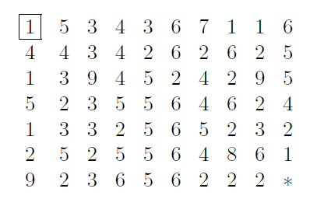

We place a figure into the top-left corner which should be moved to the bottom-right corner. The figure can be moved horizontally, verticall or diagonally (8 directions). In every step the figure can move as many cells that can be readed from it’s position!

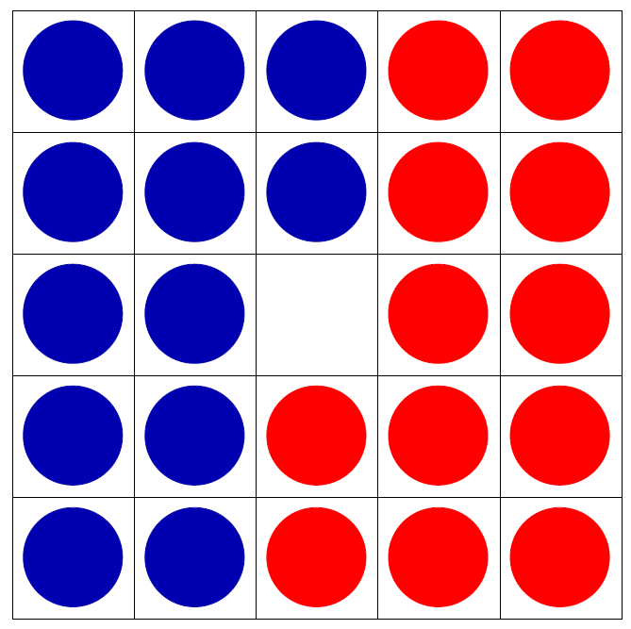

The figure shows a 5×5 board with 12 red and 12 blue discs. The blue discs are used to move down or right and the red discs are used to move up or left. At each step, you must move a disc to the empty space. A disc can be moved if it is adjacent to the empty space, or by skipping over a disc of a different colour if it is placed on an empty space. Swap the blue and red discs!